**Task 4: Managing Data**

*Year 11 ATAR Computer Science*

Mitch G. Naake

Year 11

ATAR Computer Science

25th of May, 2022

Butler College

Perth, Western Australia

Mrs. Purcell

Index

1. Database Design Information.................................................................................................................3
   1. The types of entity relationships................................................................................................3
   2. *One to One* entity relationships..................................................................................................3
   3. *Many to Many* entity relationships.............................................................................................3
   4. *One to Many* entity relationships...............................................................................................3
2. Designed Database Information.............................................................................................................4
   1. Overview....................................................................................................................................4
   2. Entity Relationship Diagram......................................................................................................4
   3. Entity Field Details.....................................................................................................................5
3. Form Design Elements...........................................................................................................................5
   1. Design Considerations...............................................................................................................5
      1. Readability.................................................................................................................... 5
      2. Navigation..................................................................................................................... 5
      3. Logical Order.................................................................................................................5
      4. Inclusivity...................................................................................................................... 6
   2. Additional Form Details.............................................................................................................6
   3. Form Images...............................................................................................................................7
4. SQL Queries to Power the App............................................................................................................19
   1. Logging in................................................................................................................................19
   2. Registration..............................................................................................................................19
   3. Get Booking Data.....................................................................................................................20
   4. Create Booking.........................................................................................................................20
   5. Edit Current Booking...............................................................................................................21
   6. Get Number of Bookings for a Workshop...............................................................................21
   7. Attendee Information for a Workshop.....................................................................................22

**Database Design Information**

*The Types of Entity Relationships*

Database design is crucial for having a smoothly running application/website infrastructure as it is the backbone of the information displayed on the users screen. There are three types of entity relationships: Many to Many (**M:N**), Many to One (**M:1**) and One to One (**1:1**). Each of these relationships have their own benefits and drawbacks in certain situations. Today’s database architects have done copious amounts of research and development and found that a **1:M** entity relationship is the most efficient in almost all circumstances. The reason for this is due to the fact that this sort of database architecture is more efficient at scale, easier for database architects to navigate and alter when needed, and overall can declutter a database. A **1:M** entity relationships by having a separate “child” table that contains conjoined information between entities, rather than creating a digital mess within a single table.

*The “One to One” Relationship*

A 1:1 relationship isn’t very common in modern database designs as it often overcomplicates databases and overall isn’t necessary. A 1:1 relationship example would be two separate records, A and B. Some elements of record A would contain elements of record B, and vice versa. This is rather inefficient as you might as well just merge record A and B together into a single record, especially if it doesn’t have too many fields when combined. The only logical instance that could be used would be splitting up user data to increase database performance, especially when working with large datasets.

*The “Many to Many” Relationship*

A M:N relationship is never used in any database architecture. The M:N relationship occurs where table *A* is able to have many links to table *B*, and table *B* is able to have many links to table *A*. The M:N entity relationship is extremely inefficient as rather than creating a new record n some sort of additional joining table, you are adding a new field (column) to the tables architecture. Not only does this look messy, but it also makes the database increasingly more complicated and inefficient to query. This is fixed by creating a “joining table”, which turns the relationship into a “Many to One”.

*The ”One to Many” Relationship*

The most commonly used, and by far the most efficient relationship in database design is the 1:M relationship. This relationship allows a database to have multiple records and additional information about a certain other record in a *joining table*. An example of this would be a *booking* table that has a record for each booking between any given *patient_id* and *doctor_id*. This allows multiple records (bookings) to be stored in the *booking* joining table, this makes the storing of booking data very simple. 1:M relationships are a great fit for almost any application and allows simpler querying and quicker lookup times. It also gives database designers the ability to have all information, such as bookings in the above example, in their own table.

**Designed Database Information**

Overview

The designed database was built based upon M:1 entity relationships. Some of the entities could have used only 1:1 relationships given the scenario, but that would be a major hassle to alter in the future if attendees were ever able to have more than a single booking and presenters able to have more than one workshop per day. Either way, M:1 relationships are easy to plan for, are the most efficient in most database architecture needs and are very easy for a human to read and understand. It also improves lookup times as you can search for a specific kind of data (E.g., bookings) from the table that is specifically used to store booking data.

Entity Relationship Diagram for the Designed Database

***Bold Underscored*** *= Primary Key (PK)*

*Underscored* *= Foreign Key (FK)*

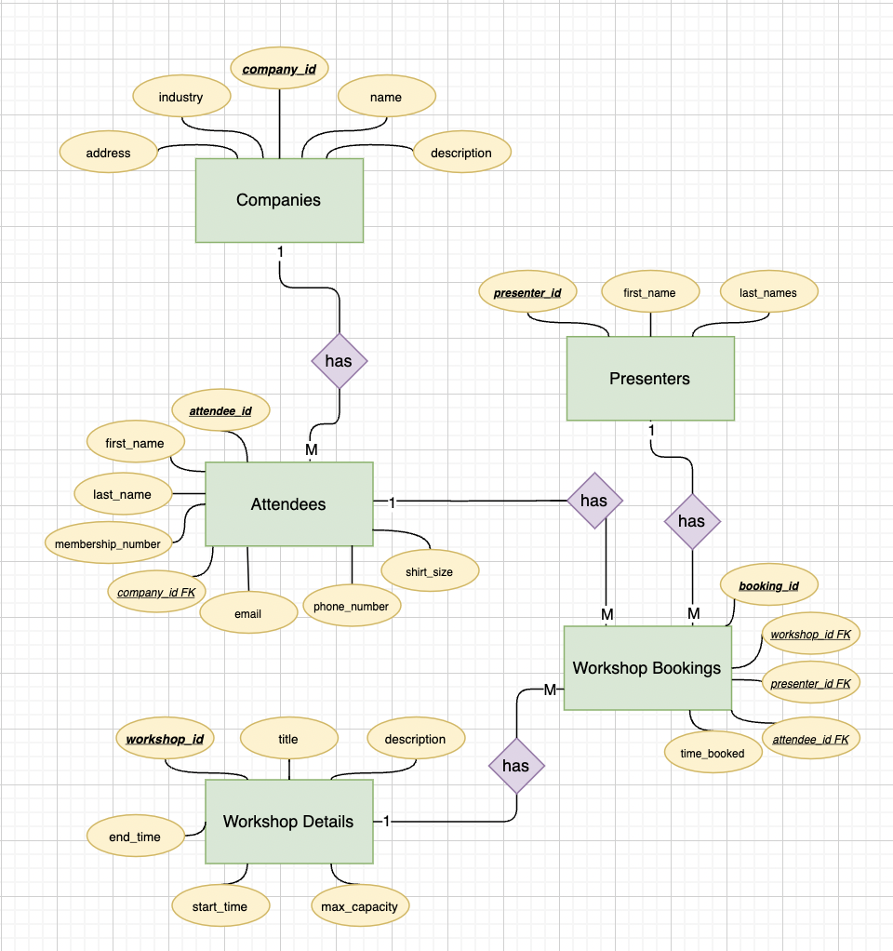

Entity Attribute Details

*Attendees*

|  |  |  |  |  |
| --- | --- | --- | --- | --- |
| **Field** | **PK** | **Data Type** | **Description** | **Constraints** |
| attendee_id | True | Integer, autoincrementing | Unique identifier for each attendee | None |
| first_name | False | Text | The First Name of the attendee | length<=25 |
| last_name | False | Text | The Last Name of the attendee | length<=25 |
| membership_number | False | Integer | The membership number given to the attendee | length<=10, Unique |
| company_id | False [FK] | Integer | The key attributed to a company in the companies table | None |
| email | False | Text | The email that the user signs up with. | length<=50, Unique |
| phone_number | False | Integer | The phone number that a user signs up with | length=11, Unique |
| shirt size | False | Text | The attendee’s shirt size | length=3 |

*Presenters*

|  |  |  |  |  |
| --- | --- | --- | --- | --- |
| **Field** | **PK** | **Data Type** | **Description** | **Constraints** |
| presenter_id | True | Integer, autoincrementing | Unique identifier for each presenter | None |
| first_name | False | Text | The presenters first name | length<=25 |
| last_name | False | Text | The presenters last name | length<=25 |
| email | False | Text | The presenters personal email address | length<=50, Unique |
| phone | False | Integer | The presenters personal phone number | length<=50, Unique |

*Companies*

|  |  |  |  |  |
| --- | --- | --- | --- | --- |
| **Field** | **PK** | **Data Type** | **Description** | **Constraints** |
| company_id | True | Integer, autoincrementing | Unique identifier for each company | None |
| name | False | Text | The name of the company | length<=50, Unique |
| description | False | Text | A description of what the company does | length<=50 |
| industry | False | Text | One or more words that details the industry that the business works in | length<=50 |

*Workshop Bookings*

|  |  |  |  |  |
| --- | --- | --- | --- | --- |
| **Field** | **PK** | **Data Type** | **Description** | **Constraints** |
| booking_id | True | Integer, autoincrementing | Unique identifier for each booking | None |
| attendee_id | False | Integer | The FK of the attendee’s booking | None, Unique |
| workshop_id | False | Integer | The FK of the workshop that the attendee has booked for | None |
| date_booked | False | Integer | The time that the booking was made, in epoch seconds. | None |
|  |  |  |  |  |

*Workshop Details*

|  |  |  |  |  |
| --- | --- | --- | --- | --- |
| **Field** | **PK** | **Data Type** | **Description** | **Constraints** |
| workshop_id | True | Integer, autoincrementing | The unique identifier for each workshop | None |
| title | False | Text | The title of the workshop | length<=100 |
| description | False | Text | The description of the content that will be covered in the workshop. | length<=250 |
| presenter_id | False | Integer, FK | The unique identifier that links to the presenter of the workshop | None |
| start_time | False | Integer | The time of workshop initiation in epoch seconds | None |
| end_time | False | Integer | The time that the workshop will finish in epoch seconds | None |
| room_number | False | Text | The number/code of the room that the workshop is taking place in. | None |
| capacity | False | Integer | The maximum number of attendees that are able to attend the workshop. | None |

**Form Design Elements**

Design Considerations

Application design is the biggest factor when it comes to user experience. If an application’s design isn’t intuitive, is hard to read, and overall doesn’t look “fine-tuned”, then user experience isn’t going to be good. When designing an application, you must ensure that your application has great readability, intuitive navigation, logical order that makes sense to users and is inclusive to all kinds of end-users.

Readability

When creating the design for the application, I used a font called Catamaran. Catamaran is a sleek and easy to read font, which allows the app to look modern and be easily read by all end users. Alongside the font, overall, the app takes a “minimalist” approach, in which large companies like Stripe, Airplane.io and Apple had a large influence. All text displayed on screen is sized correctly, to ensure that all characters that are supposed to be read, are able to be read by the user. Top off all of this, the colours that I used contrast well with each other. This prevents things like text blending in, or partially blending in with the background making it easier to read for the user. All of these considerations make for an easy-to-read application.

Navigation

When designing the navigation layout for the app, I found that apps with the least number of trailing pages are most effective at having a streamlined experience for end users. With this information, I designed the navigation to have only three main operational pages: Login/Registration, Bookings/Workshops and Settings. The login and registration panels are on the same page and can be switched between via the small toggles just above where you would input your information on the form below. To ensure consistency within the apps navigation, I also designed the booking and workshop page very similar to the login/registration page. Both are their own panels but can be easily switched between with the same toggle switch as the login/registration page, just with the correct panel names. The settings page is always available from any window that isn’t a login/registration page, the settings page uses a similar layout where users can change their information

Logical Order

To ensure that navigation is as simple as possible, logical order has to be optimised to ensure that all end users are able to make sense of the application that they’re using. Again, we condensed the app down to a simple logical order: *(Login/Registration) ---> (My Booking/Workshops) <---> (Settings)*. This order is a universal layout that is instantly recognised by users all around the world. This eliminates the extra learning curve that users would otherwise have to go through to use the app. This universal logical order allows users to instantly grasp an understanding for how the app works and begin using is efficiently as soon as possible.

Inclusivity

One of my main focus’ within the app is making is easy to operate for users of all ages, both advantaged and disadvantaged. For this, in the settings app, you are able to make the text throughout the app bold, change the size of the text and receive haptic feedback (vibration) from the app. All of these settings allow for users to tailor the app specifically for their needs, allowing them to create the best experience for themselves. On top of this, throughout the entire journey of the app, a “Need help?” button is displayed on the bottom of the screen which allows users to get into contact with a professional to aid in the users use of the app.

*Additional Application Page Information and Images*

*\* Please note, the functioning form mad differ slightly as a result of technological implications \**

Login Page

The login page requires a user to enter their membership number to log in. Realistically, there would be some sort of password that *should* be used alongside the membership number, but it was not requested for this app.

Workshops

On the Workshops page, you are able to search through all workshops with any keywords of your liking, Presenter’s First name, Last name, the title of the workshop or even a few words from the description of the workshop. Additionally, once you have selected a workshop and are viewing the additional information of it, you are able to select the “Attendees” button. This button loads a popup with the total number of attendees that are booked to view the selected workshop, as well as a scrollable view of all attendees and their non-confidential information (E.g., First Name, Last Name, Business Email, Business Phone Number and Company Name.)

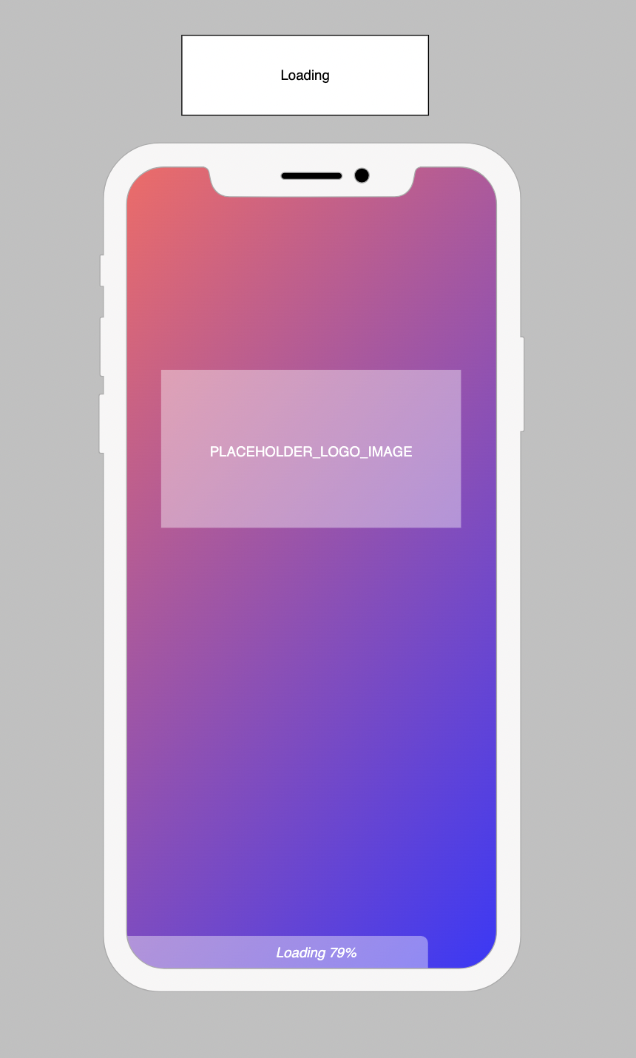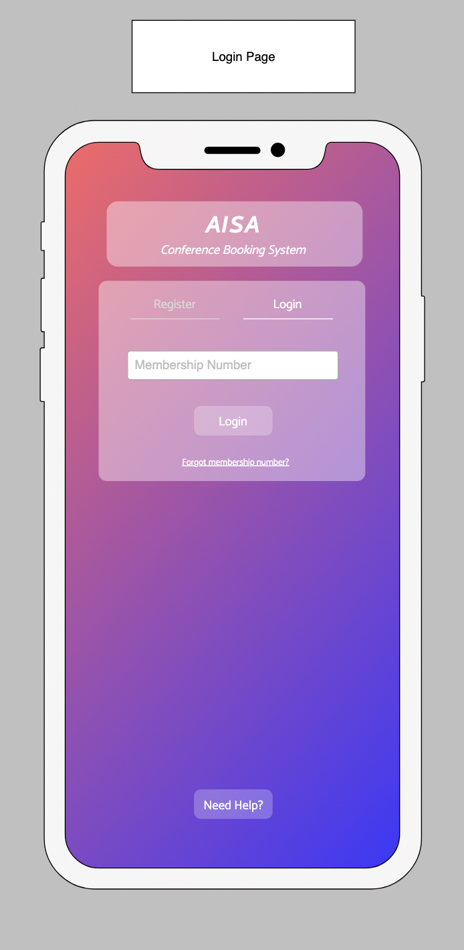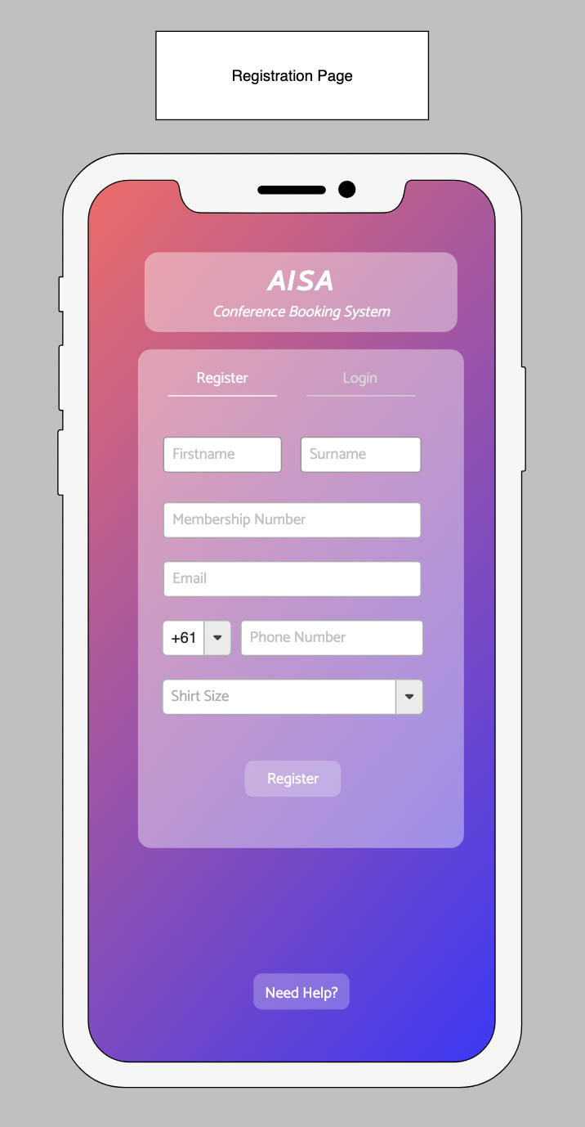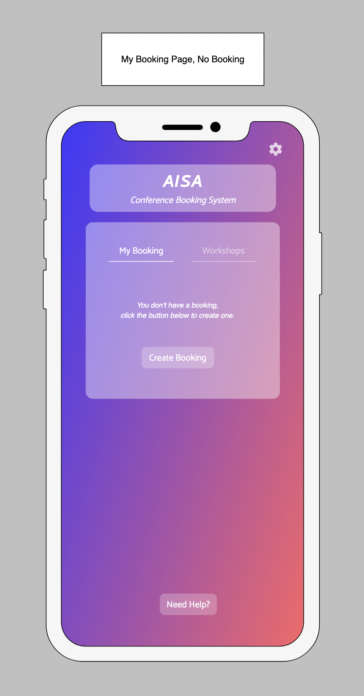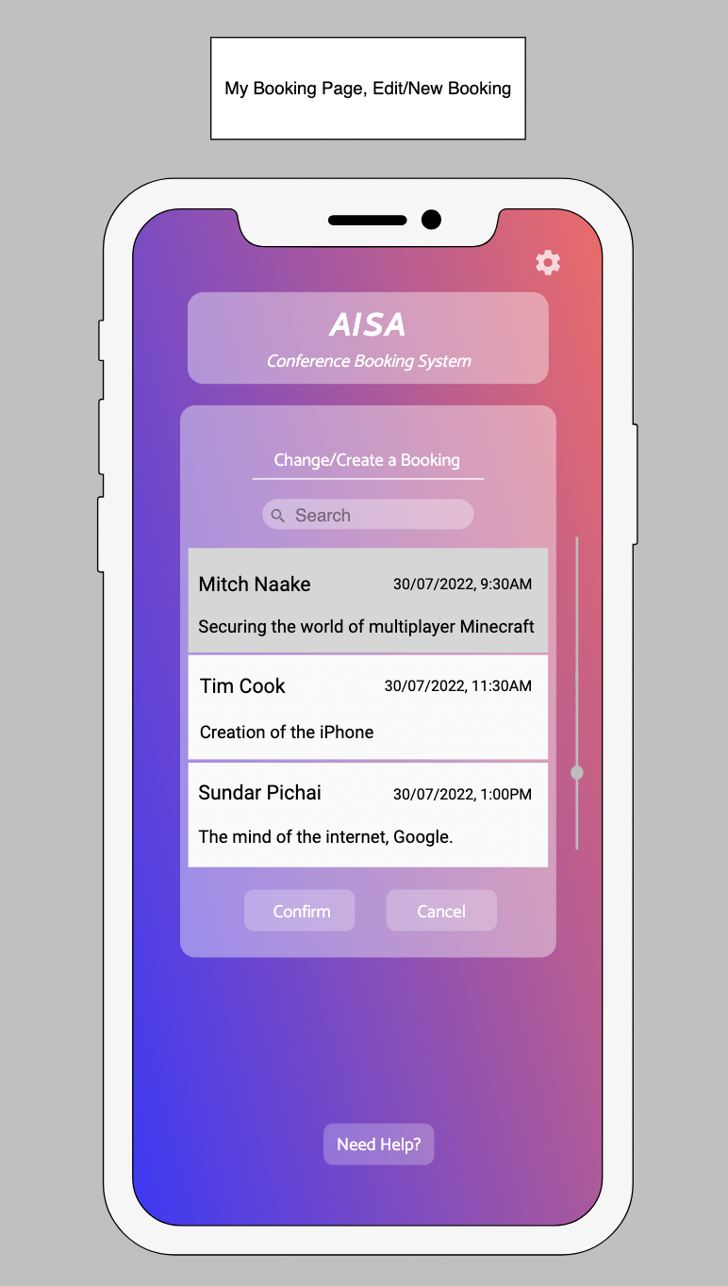

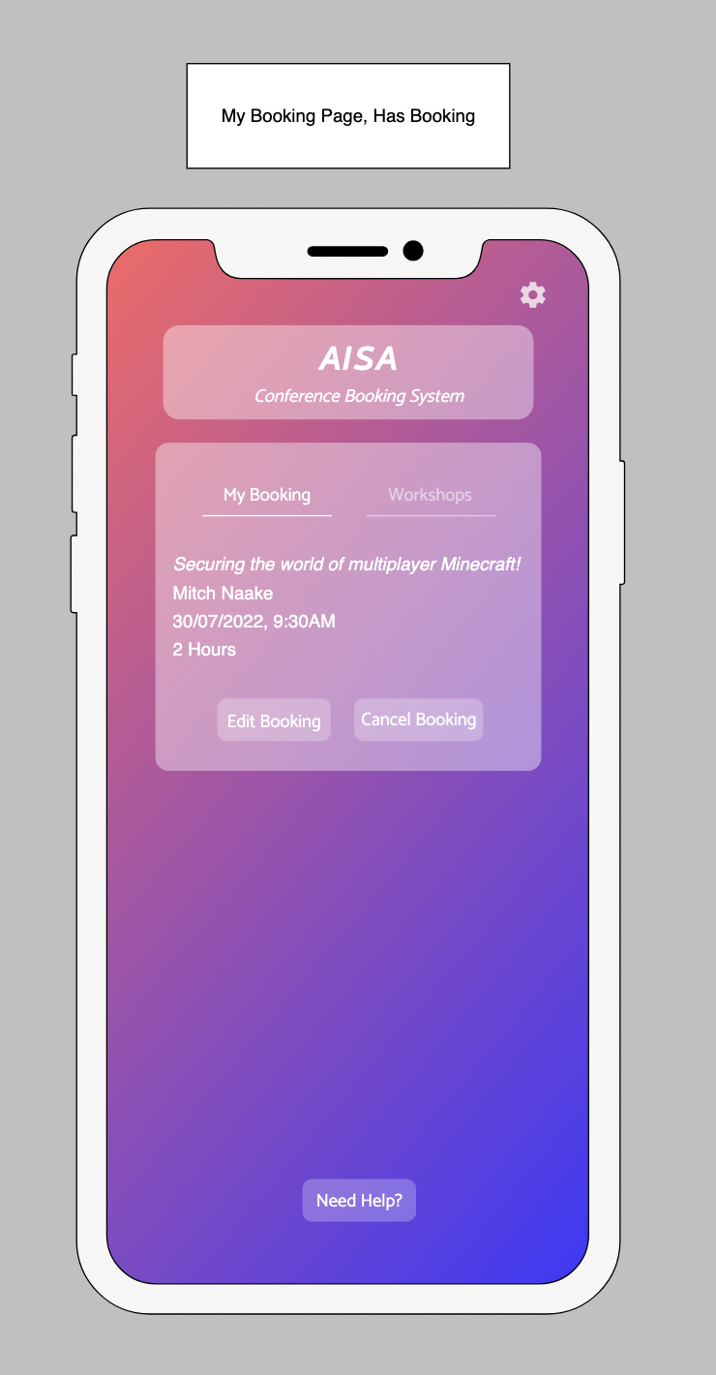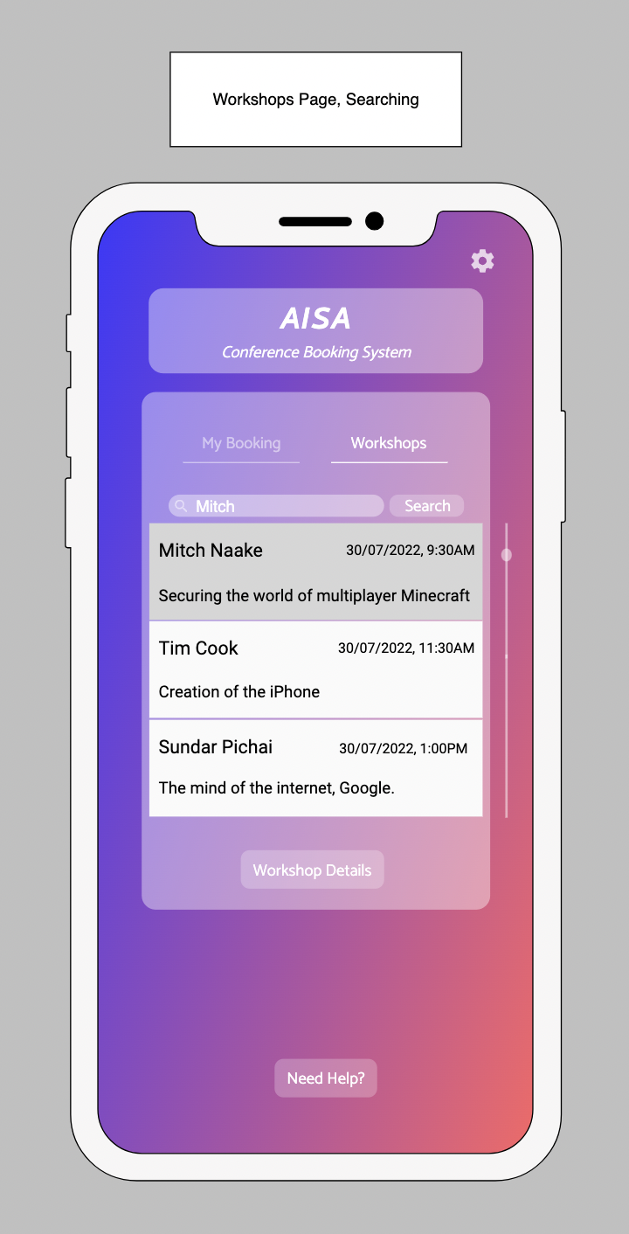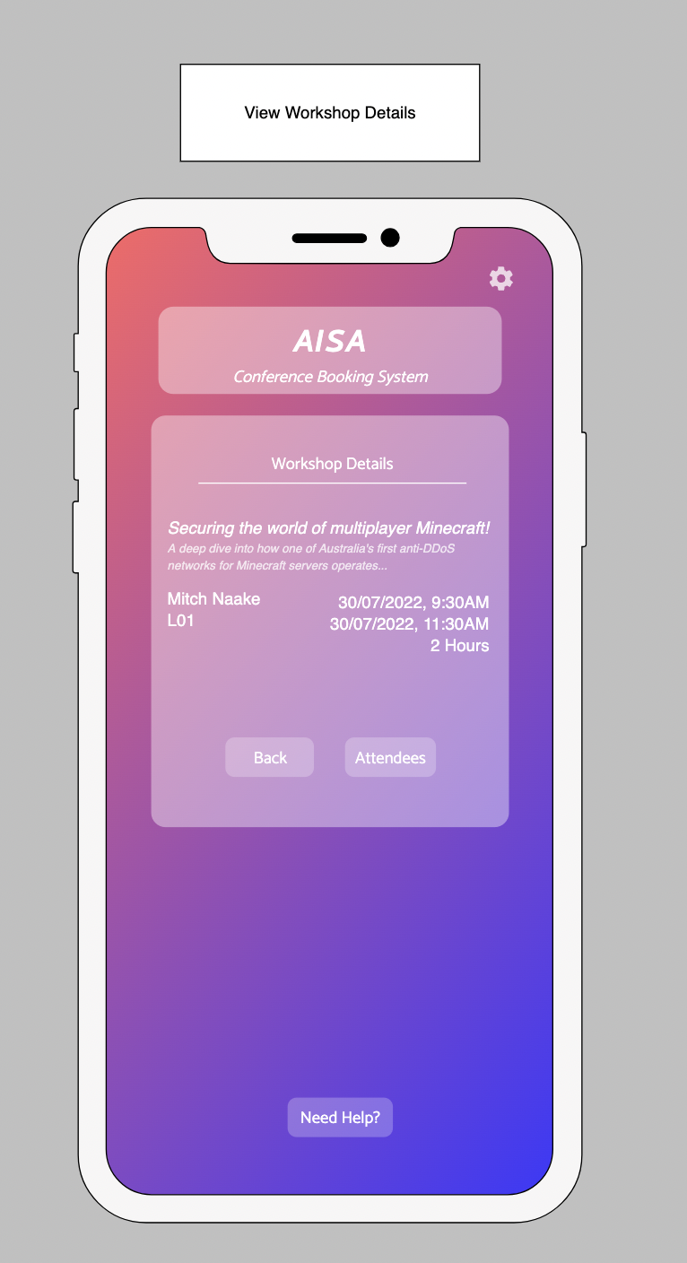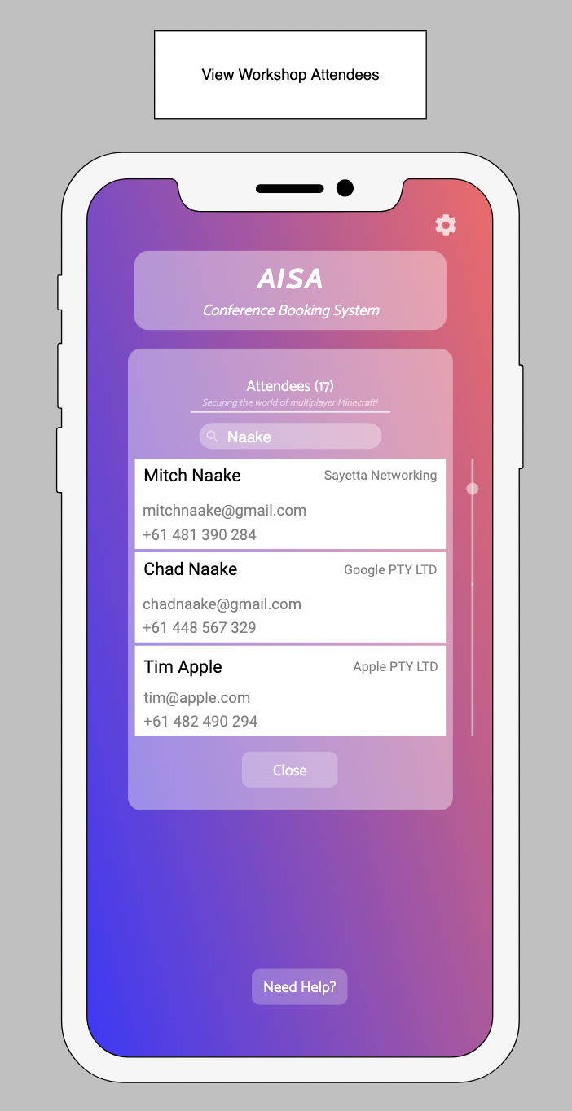

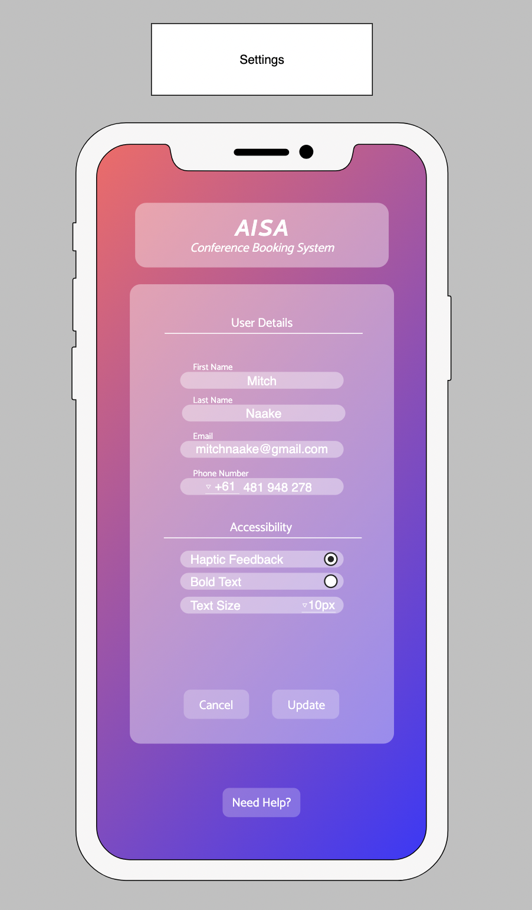

**SQL Queries Powering the App**

Logging In

*Checking whether the membership_id is attached to an account*

*Query and Example Response*

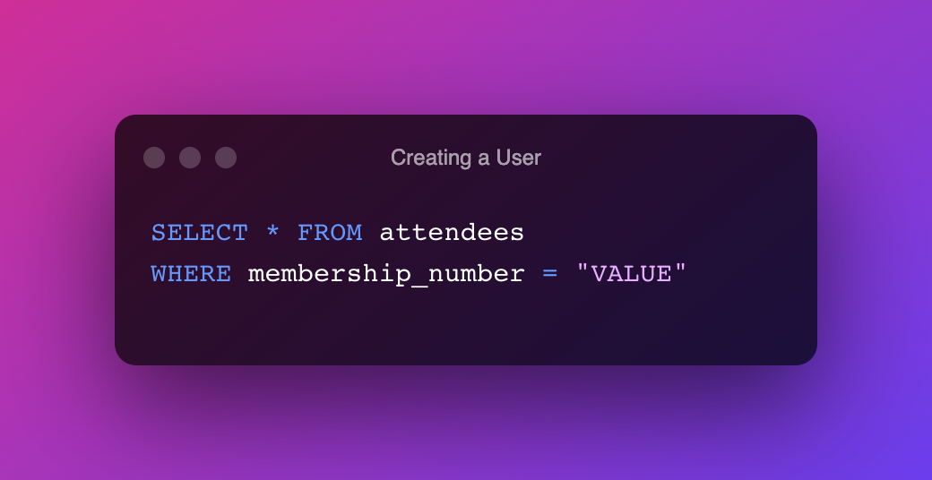

**

Registration

*Query and Response*

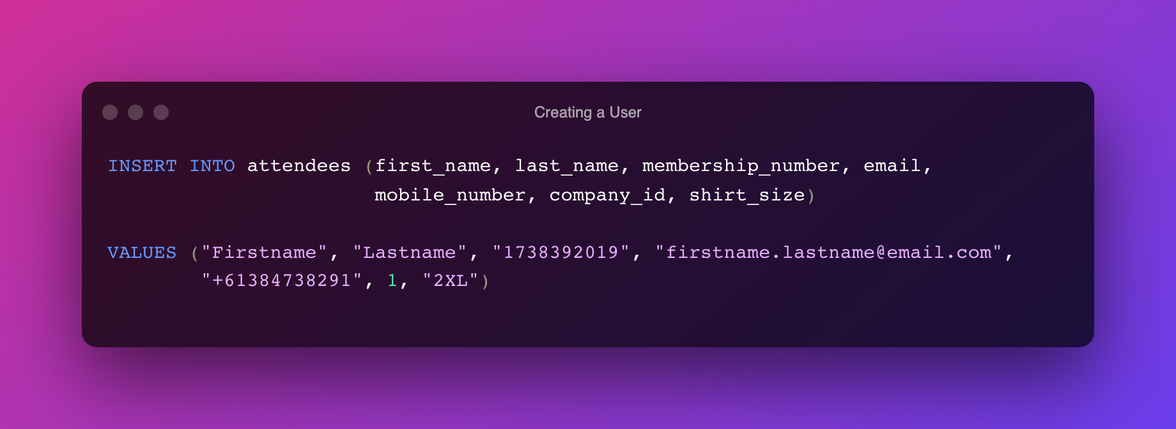

*The INSERT query does not return rows, only a success/error message.*

*NOTE: In this database setup, mobile_number and email must be unique*

Retrieving User Booking Details

*Query and Response*

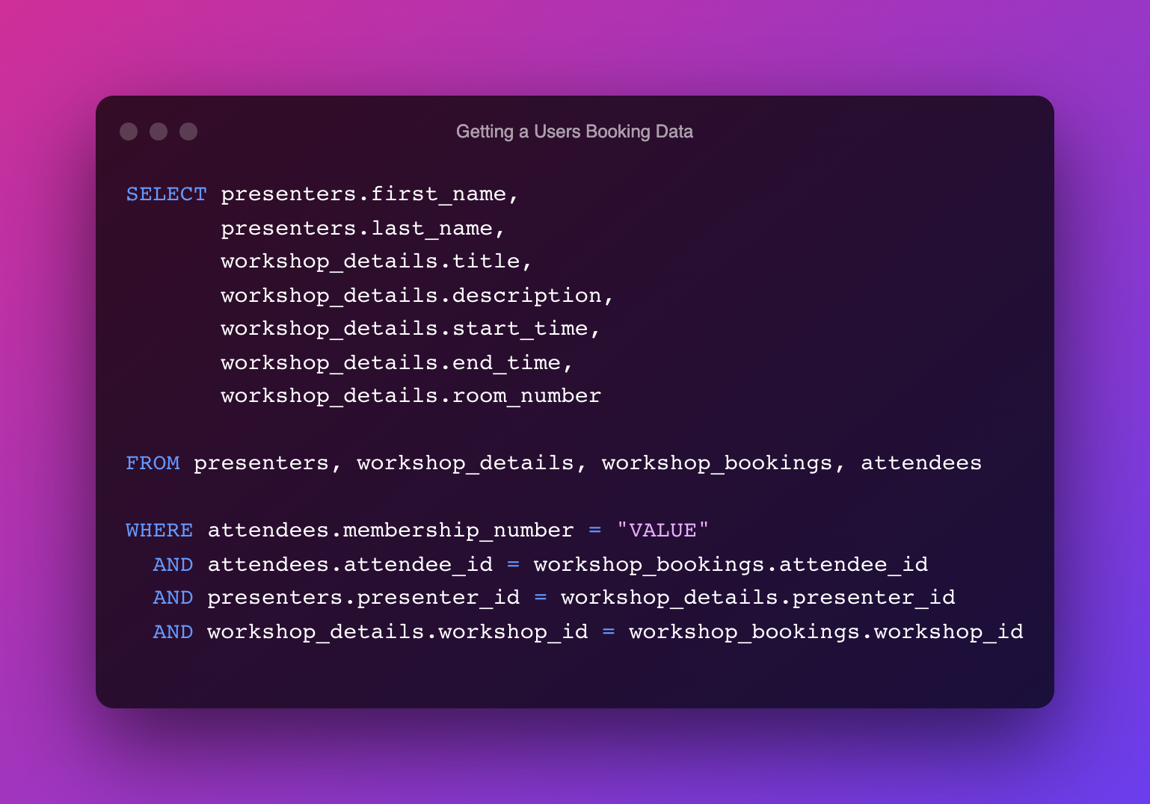

**

Creating a New Booking

*Query and Response*

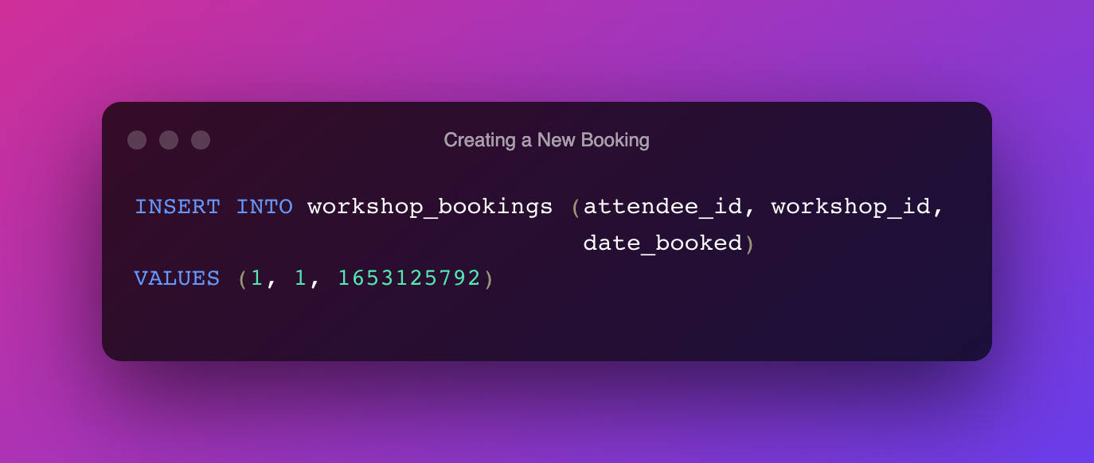

*The INSERT query does not return rows, only a success/error message.*

*NOTE: In this database setup, mobile_number and email must be unique.*

Altering the Current Booking

*Query and Response*

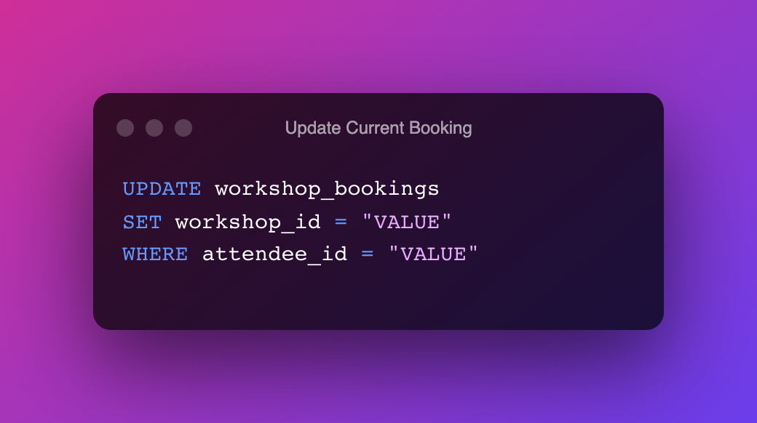

*The UPDATE query does not return rows, only a success/error message.*

Retrieving the Amount of Bookings for a Workshop

*Query and Response*

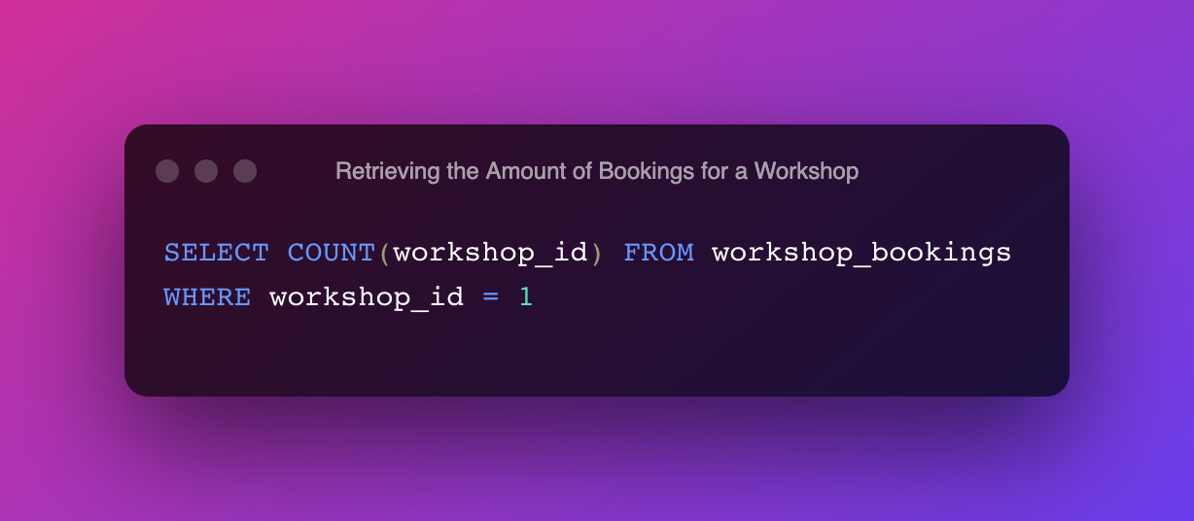

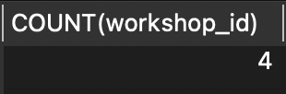

Receive all Attendees Booked for a Certain Workshop

*Query and Response*

